Chapter 3.4

Test

Choose the best answer

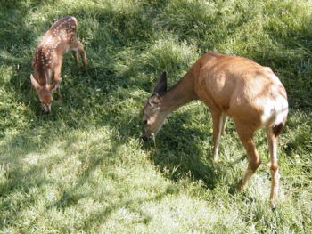 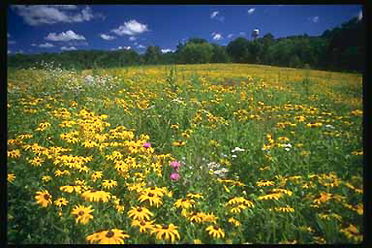

[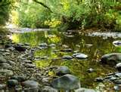](http://www.bing.com/images/search?q=creek#focal=2a9fdaa5e682f7562f68d43b84b9d8f5&furl=http://i.pbase.com/g3/28/638728/2/56074571.DSC021961.jpg)

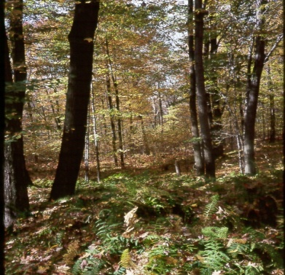 [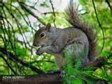](http://www.bing.com/images/search?q=squirrel#focal=18db0bbb540ba2a8df4700cac326753f&furl=http://kevoto.com/images/20081111214340_0036_grey_squirrel.jpg)

1. What is a place where living and nonliving things exist and interact with each other called
   1. Cells b. Ecosystem

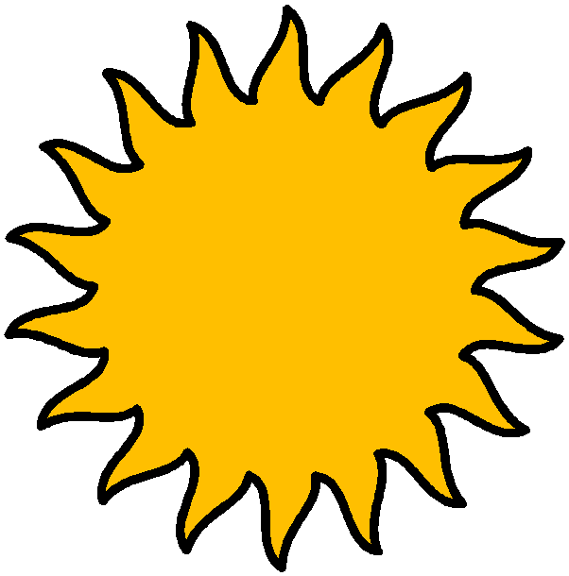 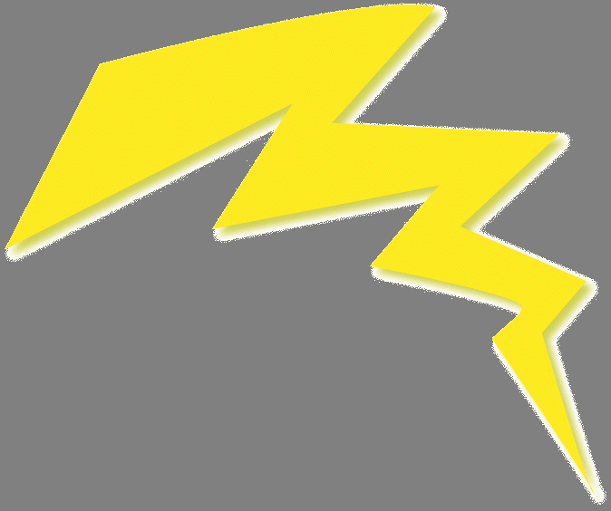

energy

1. What is the ability to cause change?
   1. Energy b. Life processes

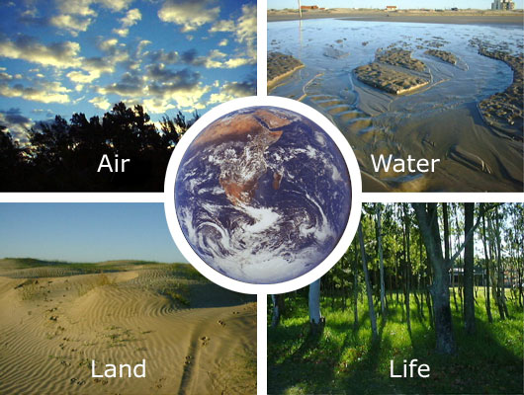



1. What is all the living and nonliving things that surround and affect an organism called?
   1. Shelter b. Environment

[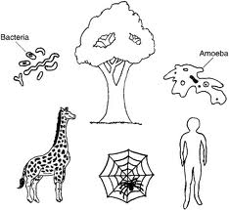](http://www.google.com/imgres?imgurl=http://01.edu-cdn.com/files/static/mcgrawhill-images/9780071410403/f0004-01.jpg&imgrefurl=http://www.education.com/study-help/article/biology-help-biology-organisms-order/&usg=__Rmbg_XuDCiBkbR13MoIGLj_Votg=&h=362&w=393&sz=50&hl=en&start=1&zoom=1&tbnid=pAoWBppOOx4SXM:&tbnh=114&tbnw=124&ei=YfjYTsnmHMrV0QH_lPXmDQ&prev=/search?q%3Dorganism%2Ba%2Bliving%2Bthing%26tbnh%3D173%26tbnw%3D188%26hl%3Den%26safe%3Dactive%26gbv%3D2%26sig%3D103401606922909726820%26biw%3D1280%26bih%3D719%26tbs%3Dsimg:CAESEgmkChYGmk47HiGxMbXXtqGWwA%26tbm%3Disch&itbs=1)

1. A living thing, such as a plant or animal is called
   1. Organism b. Energy

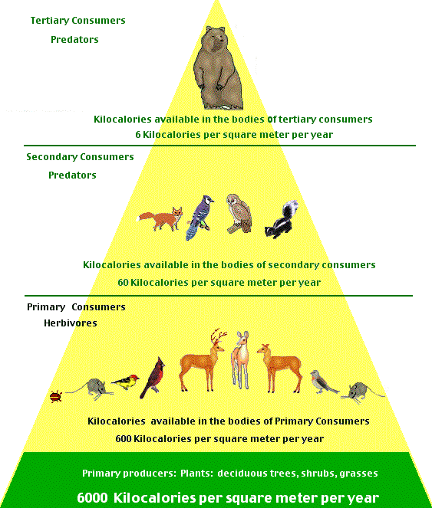

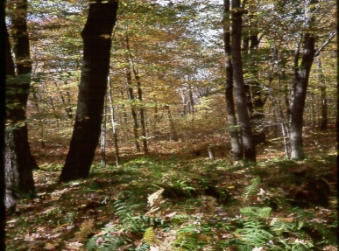

1. In Science, what is a group of plants and animals that live in the same área and interact with each other called
   1. Resource b. Community

 

1. What are all the organisms of the same kind that live together in an ecosytem called
   1. Population b. Energy

[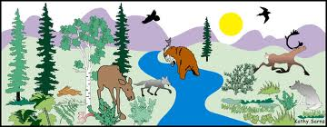](http://www.google.com/imgres?imgurl=http://igs-annessm.wikispaces.com/file/view/picture.jpg/35058953/picture.jpg&imgrefurl=http://igs-annessm.wikispaces.com/&usg=__AtsFNWw7SC2e3y5sQT8jAHvNpuY=&h=509&w=1306&sz=120&hl=en&start=1&zoom=1&tbnid=ynzlhnMpozL-4M:&tbnh=58&tbnw=150&ei=LAXZTu26BOno0QGEnJjlDQ&prev=/search?q%3Dbasic%2Bneeds%2Bof%2Bliving%2Bthings%26tbnh%3D100%26tbnw%3D257%26hl%3Den%26safe%3Dactive%26gbv%3D2%26sig%3D103401606922909726820%26biw%3D1280%26bih%3D719%26tbs%3Dsimg:CAESEgnKfOWGcymjMiFthGG4PreTjw%26tbm%3Disch&itbs=1)

air

water

food

1. What is a material or object found in nature, such as food, wáter, shelter and air that is useful to the organism.
   1. Resource b. Non living things

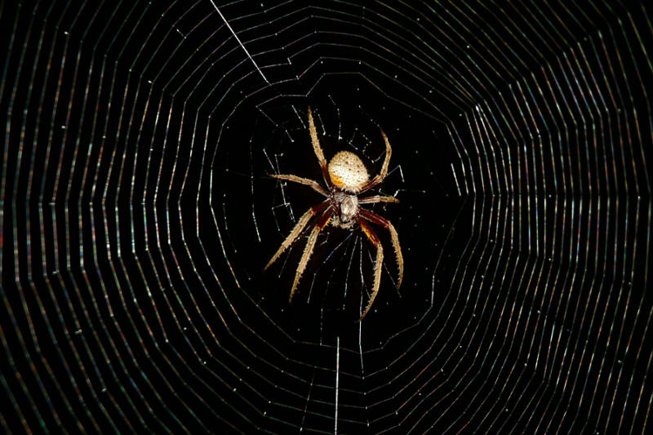 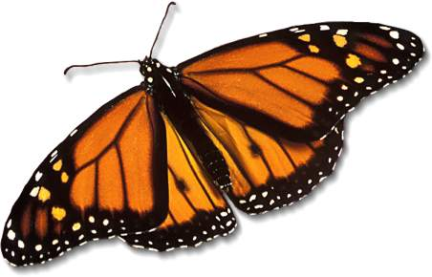

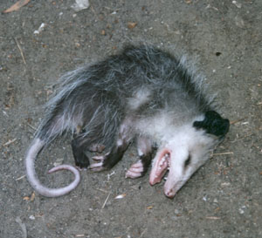 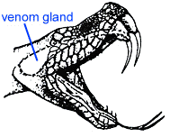

1. A behavior or body part of a living thing that helps it survive in its evironment.
   1. Population b. Adaptation



1. The way an animal typically acts in a certain situation
   1. Behavior b. Organism